Operation Manual

Bryson Potts, Joseph Earnest, Manning Owens, Steven Harrington, Tamara Mccaskill

Florida State University, Panama City

EML 4551C – Senior Design 1

Dr. Damion Dunlap



Table of Contents

**Project Overview** **3**

**Component/Module Description** **3**

**Integration** **9**

**Operation** **9**

**Troubleshooting** **10**

# Project Overview

For our senior design project, we were tasked with the challenge of engineering and manufacturing a boat for the Roboboat 2021 competition. We teamed up with the electrical engineering roboboat group to be able to use two sets of skills with the ability to make a better boat overall. However, the competition went online and was based on a slide show presentation, video, and conceptual idea of a boat. We did not place or win any money unfortunately.

Since we teamed up with the electrical engineering group, we decided that we (the mechanical engineering group) would focus on the manufacturing of the hull while the electrical engineering group would focus on the hardware and software integration of the boat. Our plans to manufacture the boat did not work out at Gulf Coast or the HPMI lab in Tallahassee, so we can make a mold out of foam and do a hand layup of the boat using fiberglass. The boat hull was completed on Saturday, July 24, 2021 and the final presentation was conducted on Monday, July 26, 2021.

# Component/Module Description

Our first concept of the boat is the following:

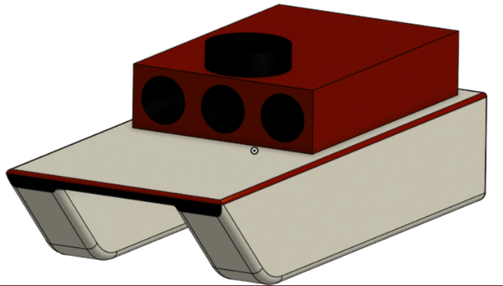

The next concept we came up with is the following:

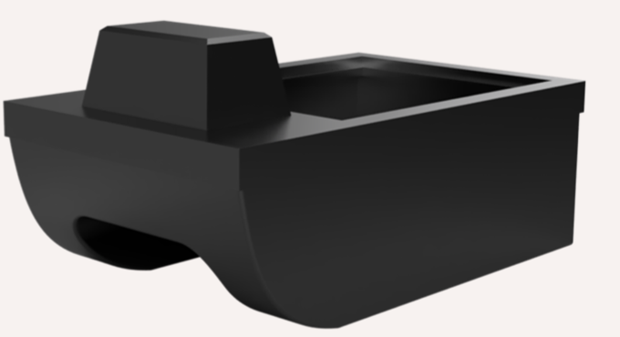

To be able to do a hand layup using fiberglass, we first had to build a mold:

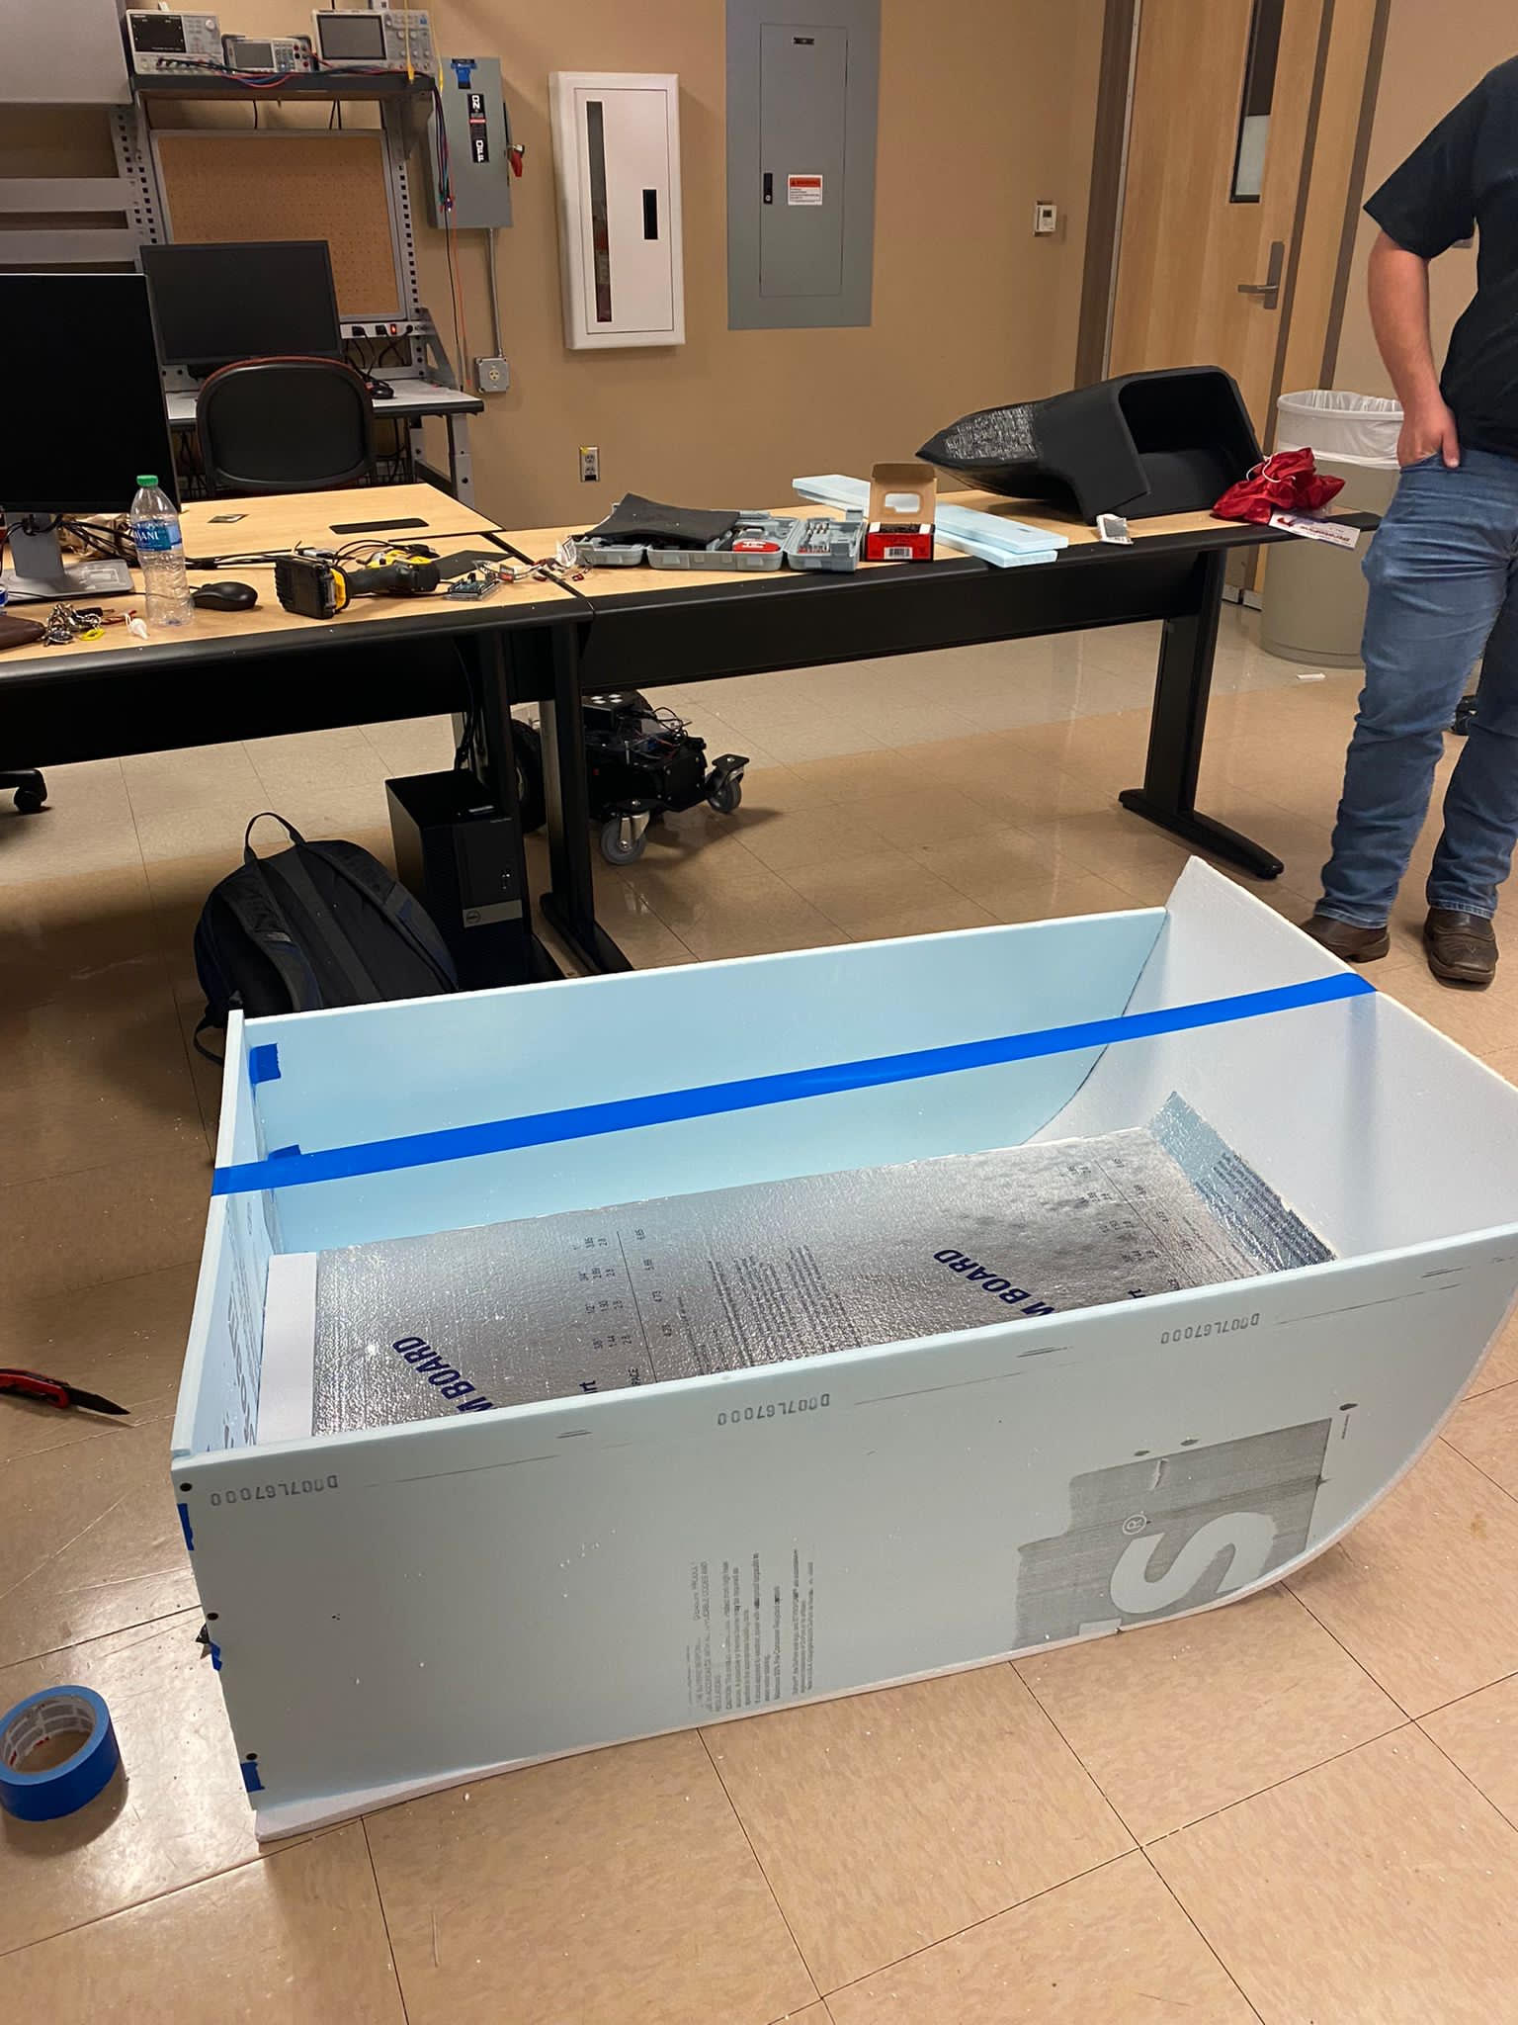

After building the mold, we did a hand layup of the fiberglass. The boat hull was 3 layers and the lid was 6 layers.

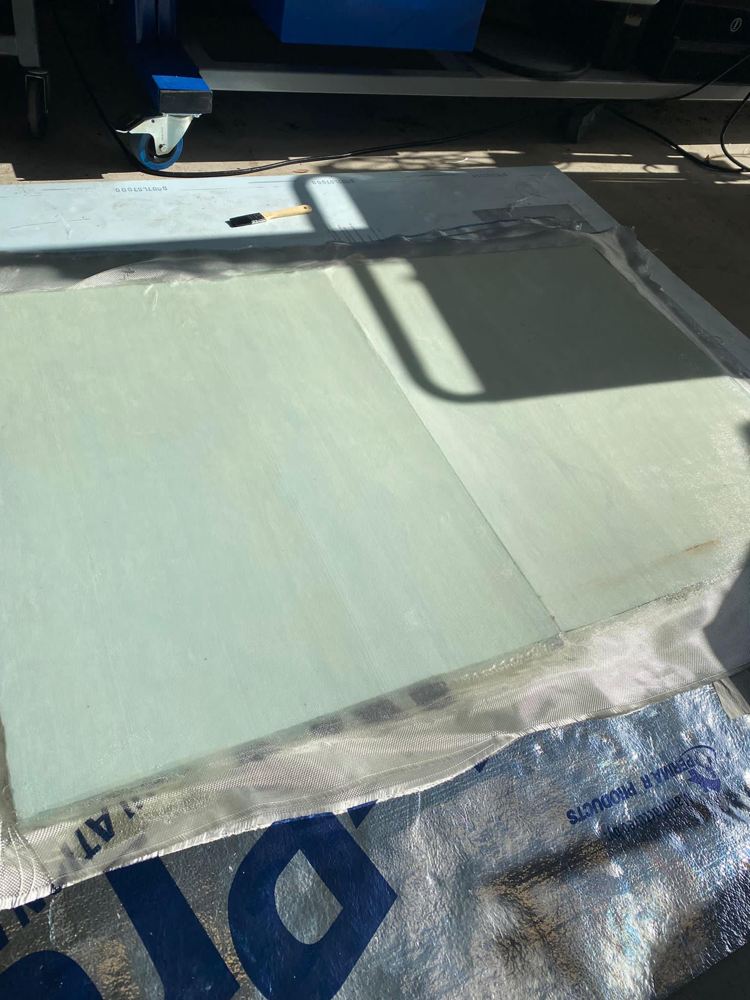

*The lid

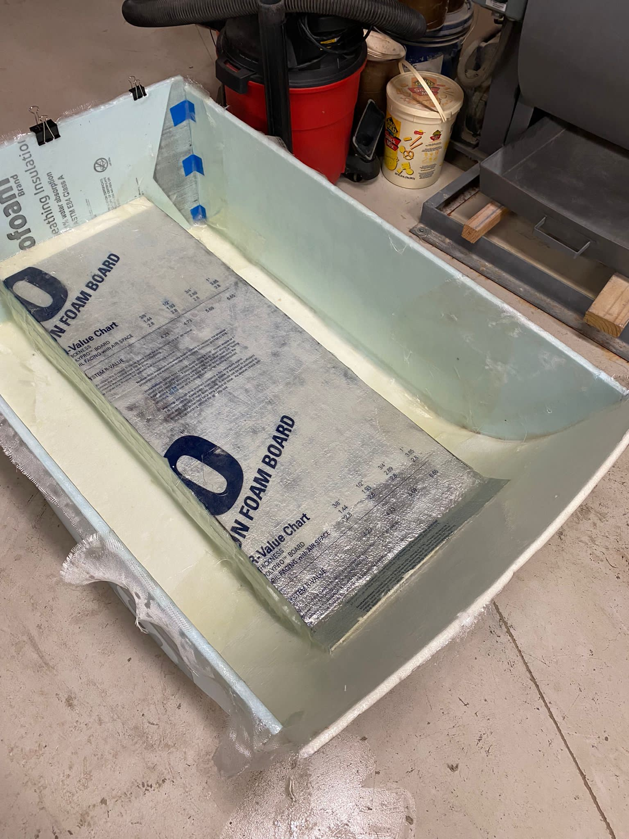

*The hull

Then we removed the mold from the dried fiberglass, checked and repaired any holes found and put it in the water for a leak test. 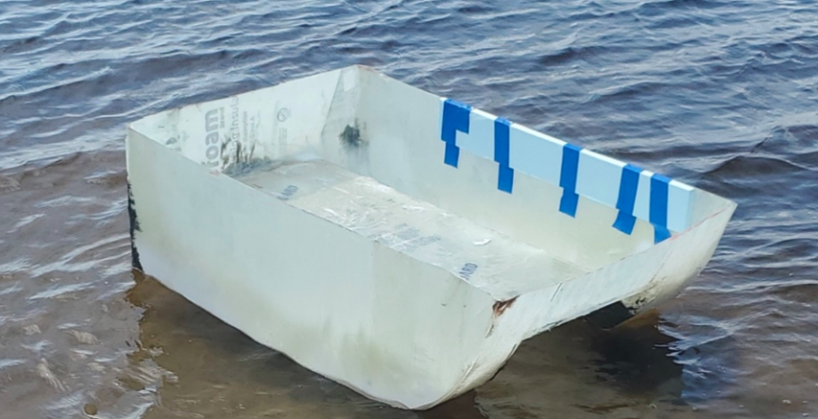

After the boat was repaired and had no leaks, the hull and lid were painted.

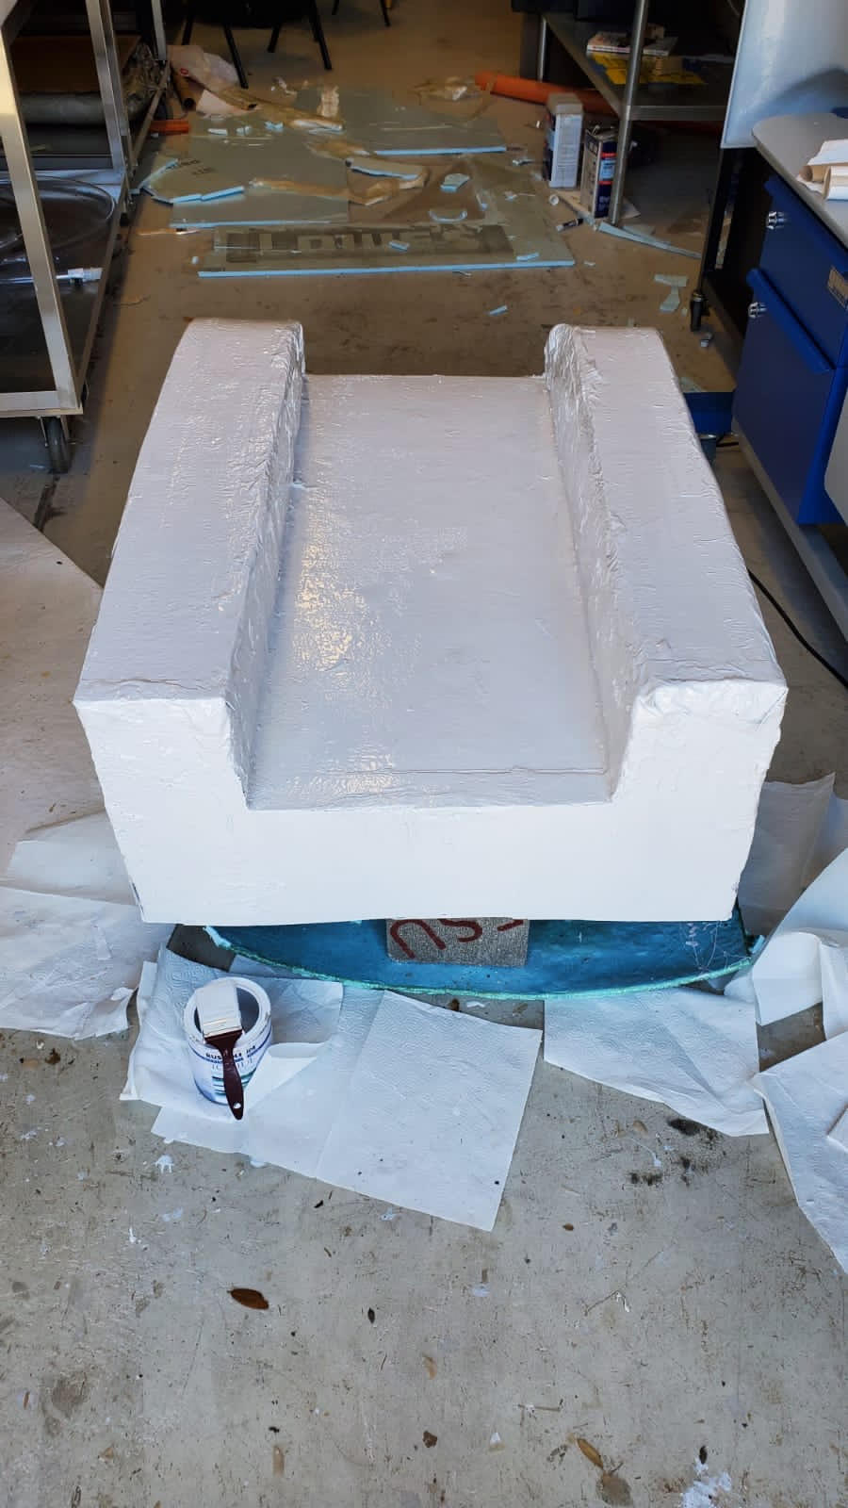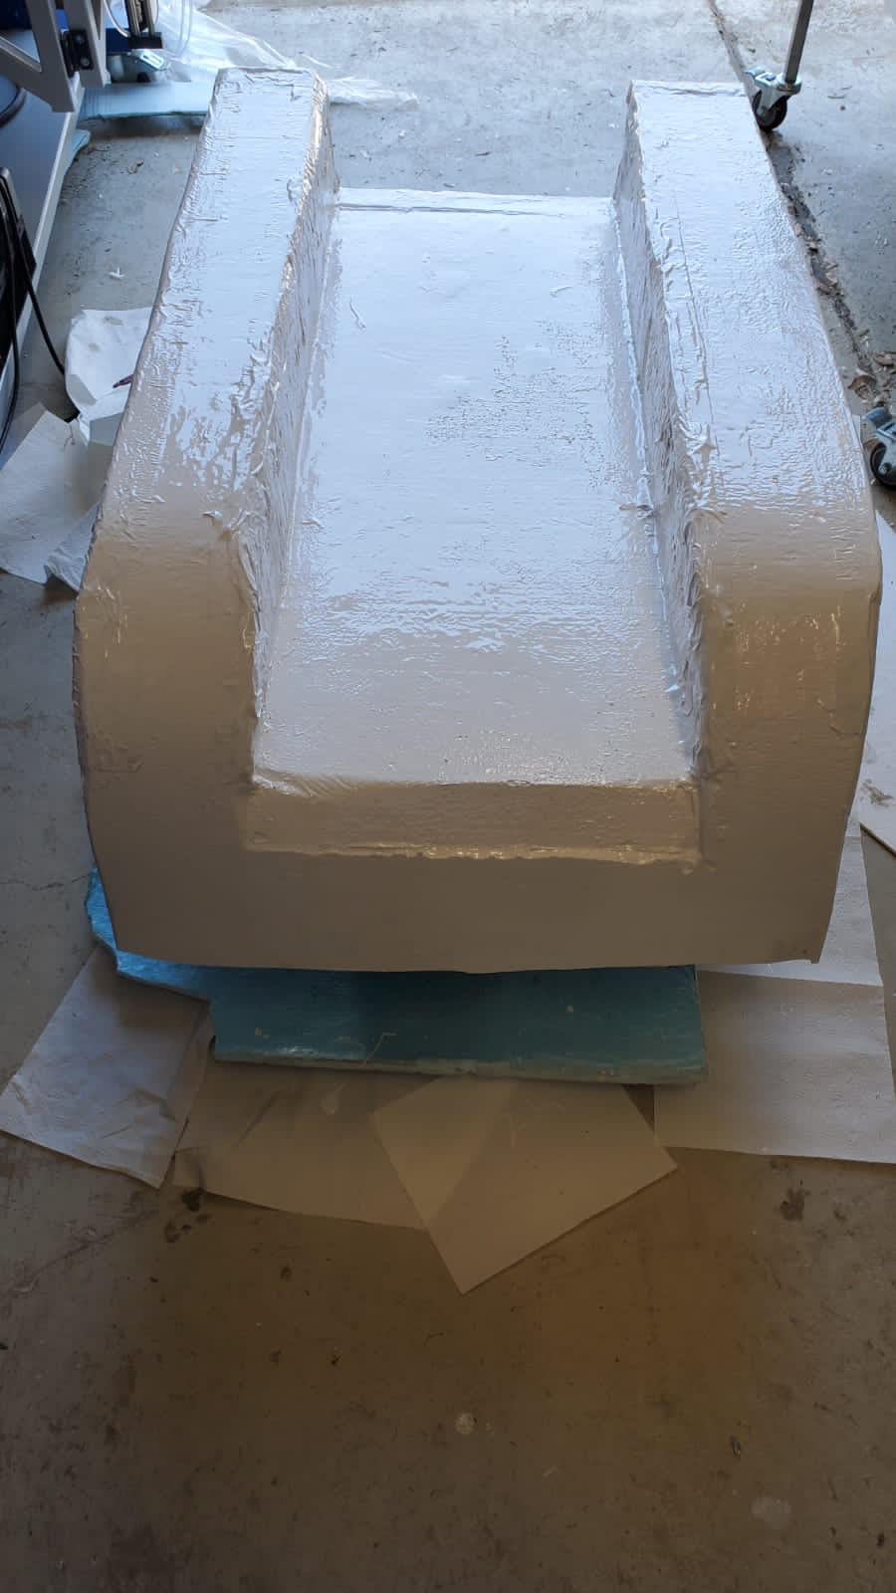

The following is a picture of the lidar tilt mechanism. This is mounted on the front of the lid.

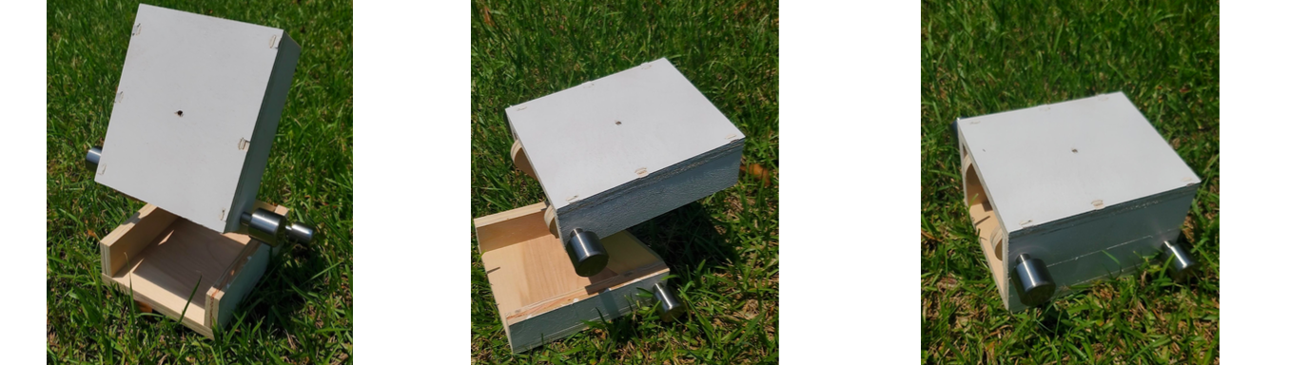

Next is the propulsion hot swap system we implemented on the boat. The bottom part of the fins are glued to the bottom part of the boat. The fins that slide off allow the propellers to be changed with ease.

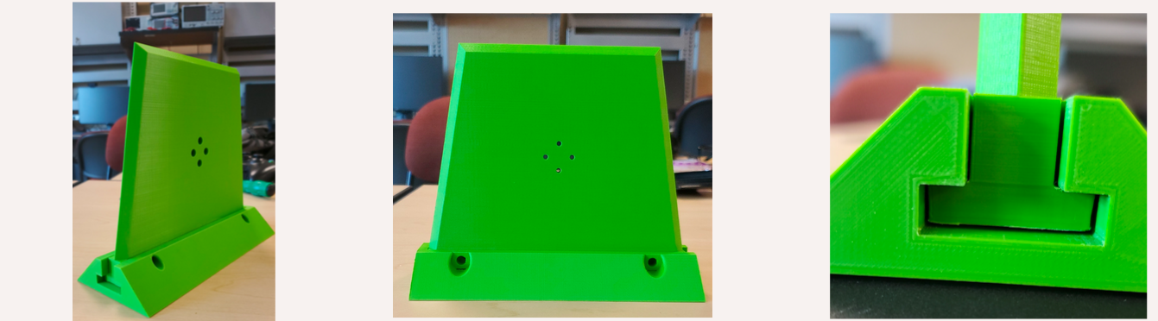

The final product is the following picture:

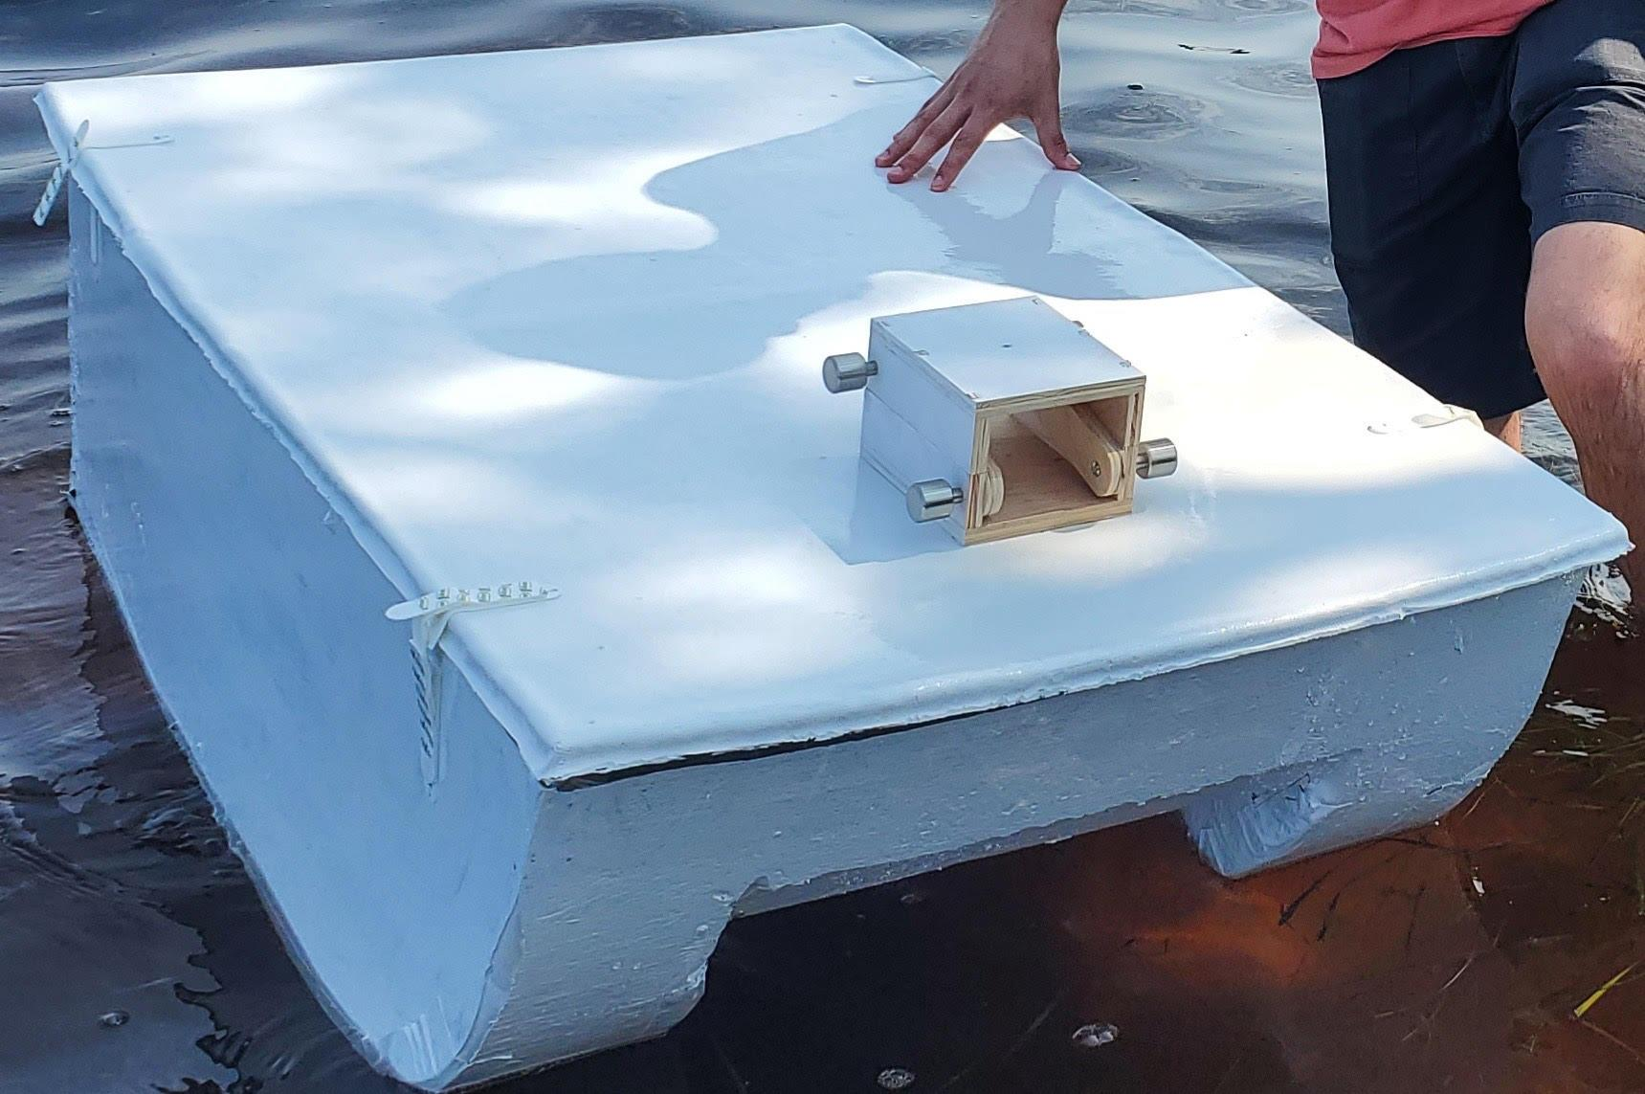

# Integration

The project was started making a mold out of foam. The mold was then sprayed with pam to help the foam not stick to the fiberglass once it was dry. Once that was made, we did a hand layup out of fiberglass using an epoxy resin for fiberglass. We did 3 layers of fiberglass for the hull and 6 layers on the lid. Also, we left the foam from the mold on the lid to act as extra support. After the fiberglass was dried, we removed the foam from it. Then we checked for and repaired any holes we found after doing multiple float tests. Once the boat was not leaking, we painted it and glued on the propulsion hot swaps and lidar tilt mechanism as our final product. The electrical engineers are going to be working on integrating the hardware and software onto the boat to allow it to be remote controllable.

# Operation

***Boat Hull***

To operate the boat hull, place the boat into the water with the pontoons going into the water first, be careful not to let water into the hull if operating without the lid. If water is let into the hull, use a towel to dry it.

***Boat Lid***

To operate the lid, place the lid on the boat hull with the tilt mechanism facing the front of the boat. Using the velcro straps, strap the lid to the boat hull to secure the lid onto the hull.

***Tilt Mechanism***

To use the tilt mechanism, loosen the silver knobs to allow for easy manipulation. Tilt the device to the desired height and tighten the bottom knobs (closest to the lid), tilt the device to the desired angle for the LiDAR to sit at and tighten the knobs (furthest from the lid). Use a Phillips head screwdriver if the device is not achieving desired stiffness.

***Propulsor Hot-Swaps***

Align the propulsor mount with the holes of the hot-swap fin, using the correct size screwdriver and screws, attach the propulsor to the hot-swap fin. Align the T joint with the hot-swap rack attached to the underside of the boat, and slide in gently, if there is friction attempt to flip the hot-swap fin around and try again, if friction still occurs lightly grease or sand the T joint on the fin.

# Troubleshooting

Since our portion of the project focused on the manufacturing and fabrication of the boat hull, the main concern with that is if the boat starts leaking. To be able to fix a leak, use either flex seal or fiberglass hole repair in order to cover the hole completely. Let the remedy dry the appropriate amount of time and then test and make sure no water leaks into the boat. If the LiDAR tilt mechanism or the propulsor hot-swaps were to come off, be sure to apply a strong, waterproof adhesive (gorilla glue, super glue, etc.) and let it sit for an appropriate amount of time prior to putting it in the water. Lastly, if the velcro straps were to come unglued, be sure to apply the appropriate adhesive and let it sit and dry, or a feasible option is to replace the velcro.